Charlene Butler
EEE304
Lab 2
Overview of Results:

- 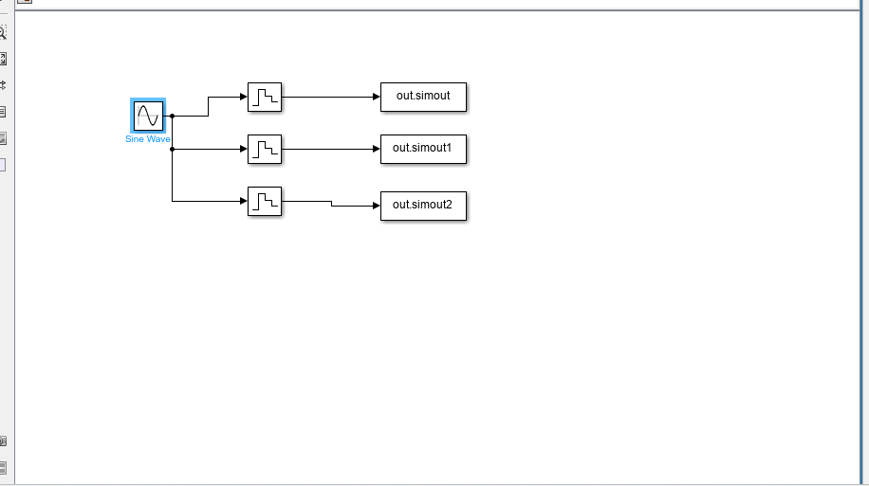
%80
Hzdata80_2 = data80(:)';
fft_80 = fft(data80_2);
fft_80 = fftshift(fft_80);
N80 = length(fft_80);
f80 = (80/N80)*(-(N80-1)/2:(N80-1)/2);
figure;
subplot(2,1,1);
plot(time80',data80_2);
title('Plot of sampled signal (fs=80 Hz)');
ylabel('Amplitude');
xlabel('Time');
subplot(2,1,2);
plot(f80,abs(fft_80)/N80);
title('Plot of Magnitude of FFT');
ylabel('Magnitude');
xlabel('frequency');
%400
Hzdata400_2 = data400(:)';
fft_400 = fft(data400_2);
fft_400 = fftshift(fft_400);
N400 = length(fft_400);
f400 = (400/N400)*(-(N400-1)/2:(N400-1)/2);
figure;
subplot(2,1,1);
plot(time400',data400_2);
title('Plot of sampled signal (fs=400 Hz)');
ylabel('Amplitude');
xlabel('Time');
subplot(2,1,2);
plot(f400,abs(fft_400)/N400);
title('Plot of Magnitude of FFT');
ylabel('Magnitude');
xlabel('frequency');
%1000
Hzdata1000_2 = data1000(:)';
fft_1000 = fft(data1000_2);
fft_1000 = fftshift(fft_1000);
N1000 = length(fft_1000);
f1000 = (1000/N1000)*(-(N1000-1)/2:(N1000-1)/2);
figure;
subplot(2,1,1);
plot(time1000',data1000_2);
title('Plot of sampled signal (fs=1000 Hz)');
ylabel('Amplitude');
xlabel('Time');
subplot(2,1,2);
plot(f1000,abs(fft_1000)/N1000);
title('Plot of Magnitude of FFT');
ylabel('Magnitude');
xlabel('frequency');

fs=20000;
[b,a] = butter(6,(70*2)/fs, 'low');
Fil = tf(b,a,1/fs);

%80
Hzdata80up = upsample(data80_2, (20000/80));
data80up = data80up(1:end-249);
time80_2 = linspace(0,time80(end),length(data80up));
figure;
plot(time80_2,data80up);
reconstructed80 = lsim(Fil,data80up,time80_2);
r_N80 = length(reconstructed80);
figure;
subplot(2,1,1);
plot(time80_2,reconstructed80);
title('Reconstructed signal (fs=80 Hz)');
ylabel('Amplitude');
xlabel('Time');
r_fft_80 = fft(reconstructed80);
r_fft_80 = fftshift(r_fft_80);
r_f80 = (20000/r_N80)*(-(r_N80-1)/2:(r_N80-1)/2);
subplot(2,1,2);
plot(r_f80,abs(r_fft_80)/N80);
title('Plot of Magnitude of FFT');
ylabel('Magnitude');

%400
Hzdata400up = upsample(data400_2, (20000/400));
data400up = data400up(1:end-49);
time400_2 = linspace(0,time400(end),length(data400up));
reconstructed400 = lsim(Fil,data400up,time400_2);
figure;subplot(2,1,1);
plot(time400_2,reconstructed400);
title('Reconstructed signal (fs=400 Hz)');
ylabel('Amplitude');
xlabel('Time');
r_fft_400 = fft(reconstructed400);
r_fft_400 = fftshift(r_fft_400);
r_N400 = length(r_fft_400);
r_f400 = (20000/r_N400)*(-(r_N400-1)/2:(r_N400-1)/2);
subplot(2,1,2);
plot(r_f400,abs(r_fft_400)/r_N400);
title('Plot of Magnitude of FFT');
ylabel('Magnitude');
xlabel('frequency');

%1000
Hzdata1000up = upsample(data1000_2, (20000/1000));
data1000up = data1000up(1:end-19);
time1000_2 = linspace(0,time1000(end),length(data1000up));
reconstructed1000 = lsim(Fil,data1000up,time1000_2);
figure;subplot(2,1,1);
plot(time1000_2,reconstructed1000);
title('Reconstructed signal (fs=1000 Hz)');
ylabel('Amplitude');
xlabel('Time');
r_fft_1000 = fft(reconstructed1000);
r_fft_1000 = fftshift(r_fft_1000);
r_N1000 = length(r_fft_1000);
r_f1000 = (20000/r_N1000)*(-(r_N1000-1)/2:(r_N1000-1)/2);
subplot(2,1,2);
plot(r_f1000,abs(r_fft_1000)/r_N1000);
title('Plot of Magnitude of FFT');
ylabel('Magnitude');
xlabel('frequency');
- 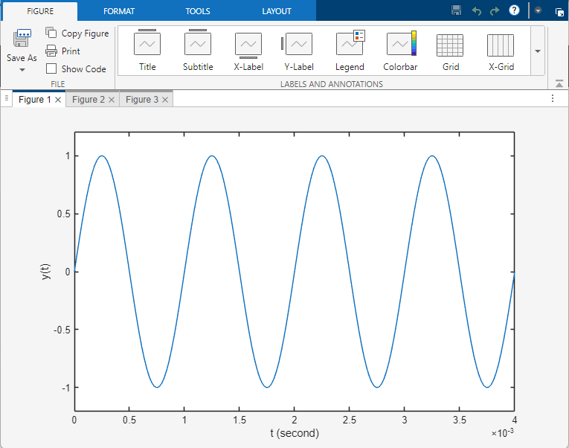
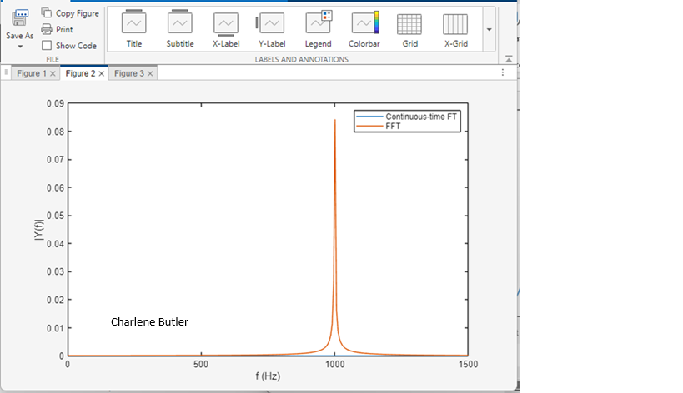
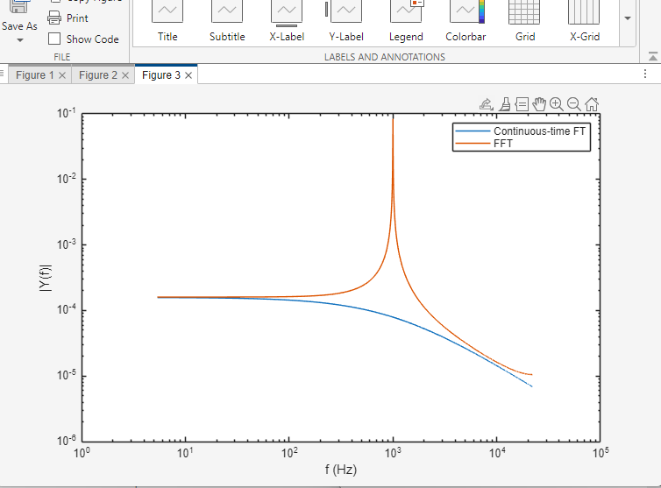

Conclusion: The continuous-time FT and the FFT produce similar results, but due to the truncation of the sinusoid, there is some aliasing in the continuous-time FT.

- 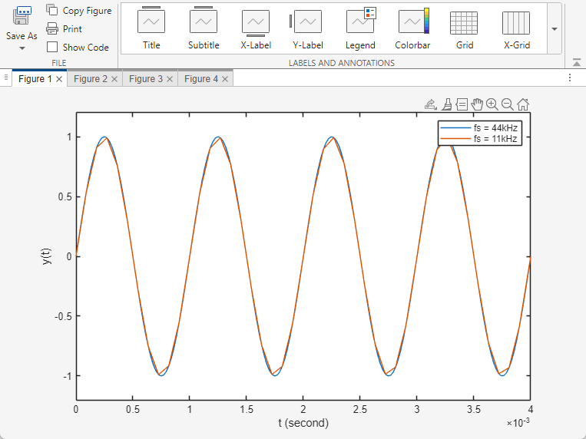
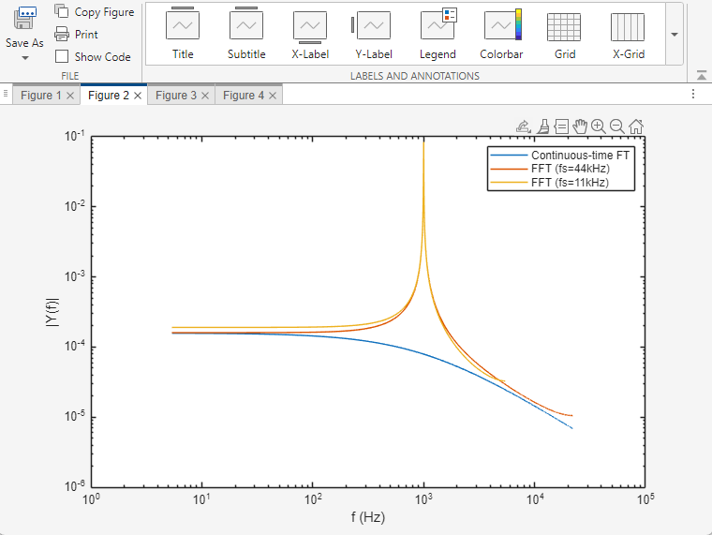
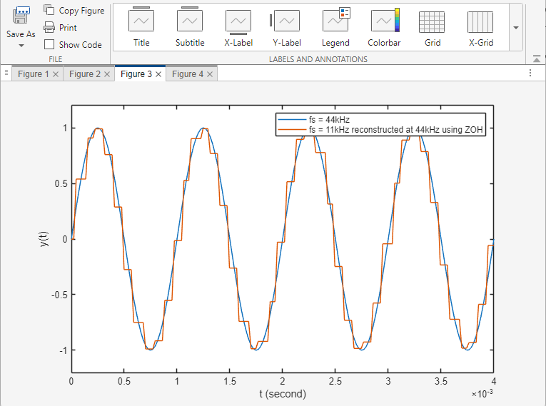
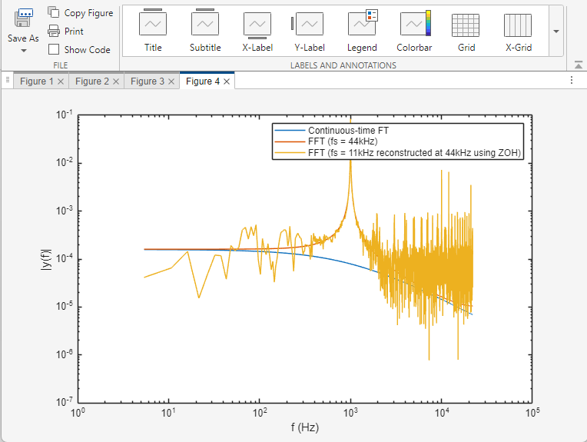

Conclusion: The aliasing effect of the 44 kHz signal is not changed but the 11 kHz signal aliasing effect is increased.

- 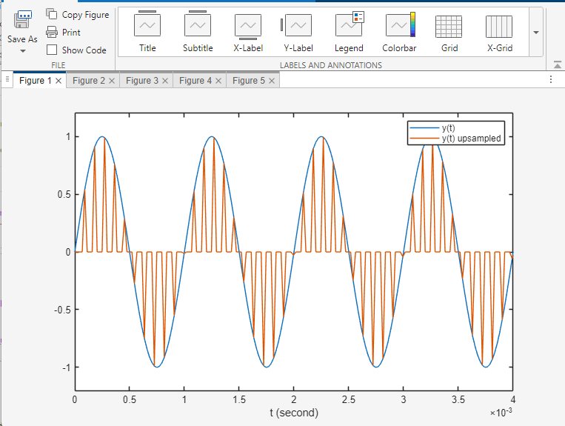
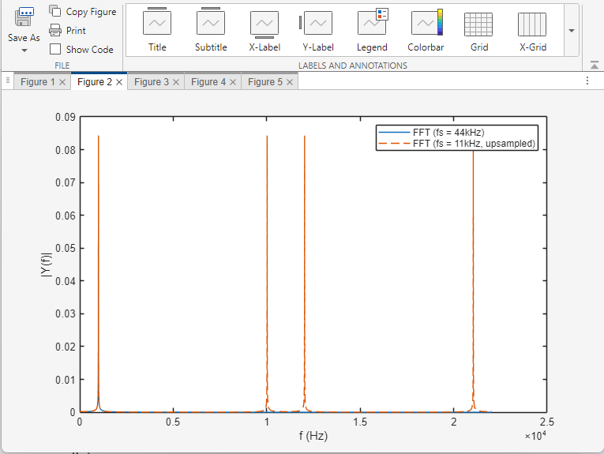
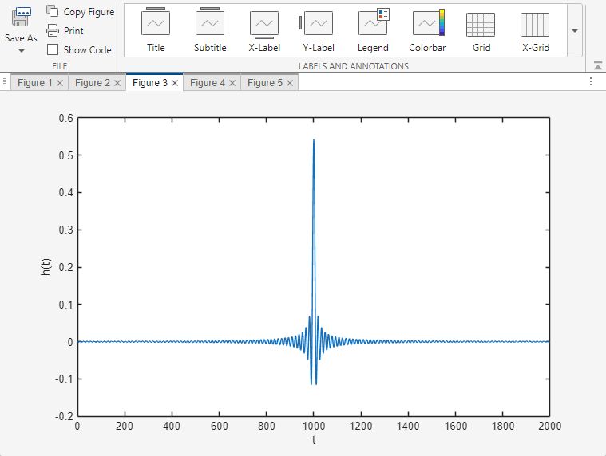
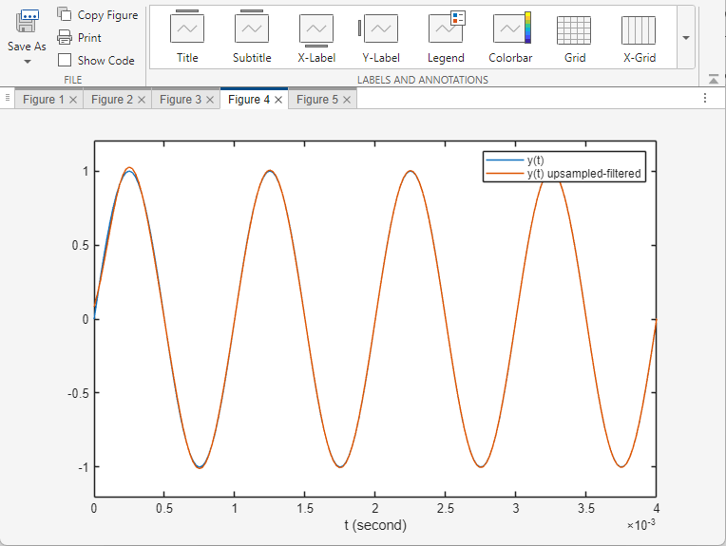
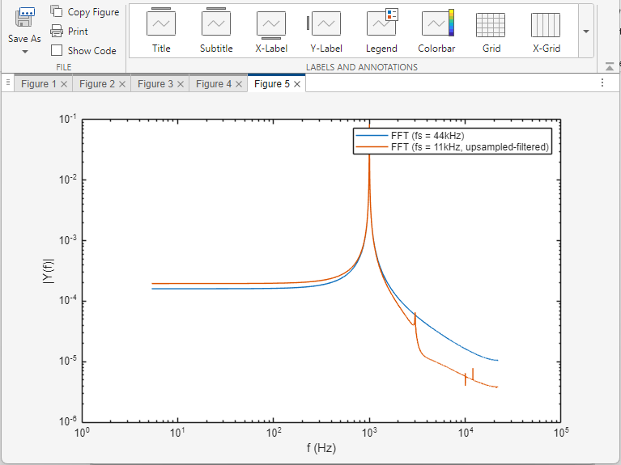

Conclusion: After the 11 kHz signal is reconstructed, it becomes different from the original sound, including having a humming sound. After the reconstructed signal is upsampled and filtered, it becomes similar to the original sound.

- [1, 100, 100, 1]
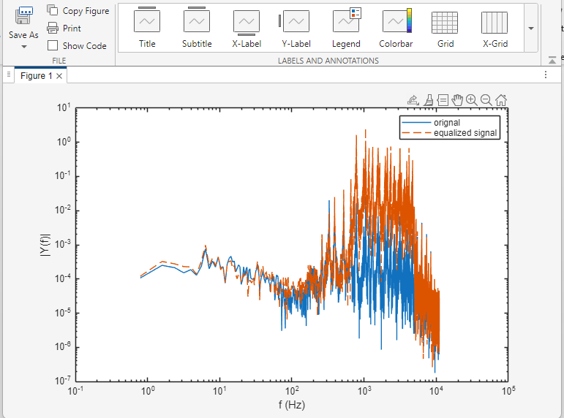

[1, 11, 111, 1111]
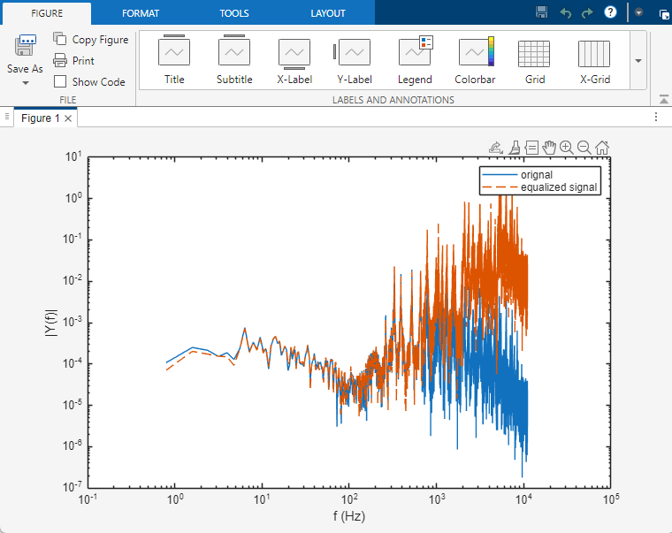

[1111, 111, 11, 1]
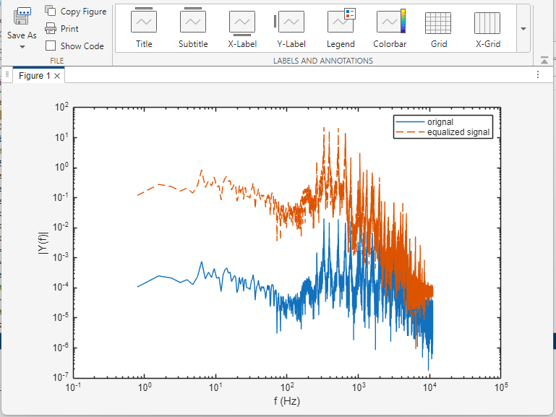

[100, 1, 1, 100]
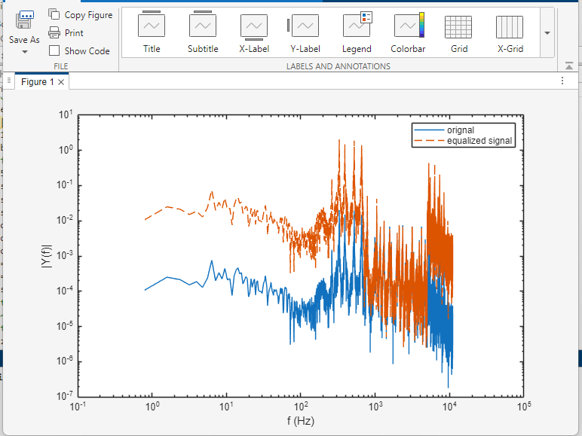

Conclusion: Yes, the frequency response does correspond to what I entered. When inputting [1, 11, 111, 1111], the Y(f) increased just like the inputs, whereas when inputting [1111, 111, 11, 1], the Y(f)decreased just like the inputs.

